 | Course Name: Advanced Web Technology | EXPERIMENT NO. 5
 | Course Code: 20CP314P  Faculty: Komal Singh | Branch: CSE
 | Course Code: 20CP314P  Faculty: Komal Singh | Semester: VI
Submitted by: Harsh Shah
Roll no: 21BCP359

Objective: Create your first React code
- Create a “hello world” react app.
index.js
import React from "react";
import ReactDOM from "react-dom/client";
import "./index.css";
import App from "./App";
import reportWebVitals from "./reportWebVitals";

const root = ReactDOM.createRoot(document.getElementById("root"));
root.render(
<React.StrictMode>
<App />
</React.StrictMode>
);
reportWebVitals();

App.js
import "./App.css";
import Home from "./components/Home";
import { BrowserRouter, Routes, Route } from "react-router-dom";
function App() {
return (
<div>
<BrowserRouter>
<Routes>
<Route path="/" element={<Home />}>
{" "}
</Route>
</Routes>
</BrowserRouter>
</div>
);
}
export default App;

Home.jsx
import React from "react";
const Home = () => {
return
<div>
<header className="App-header">
<h2>Hello World 👋</h2>
<p>This is a Hello World Page</p>
</header>
</div>
);
};
export default Home;

Output

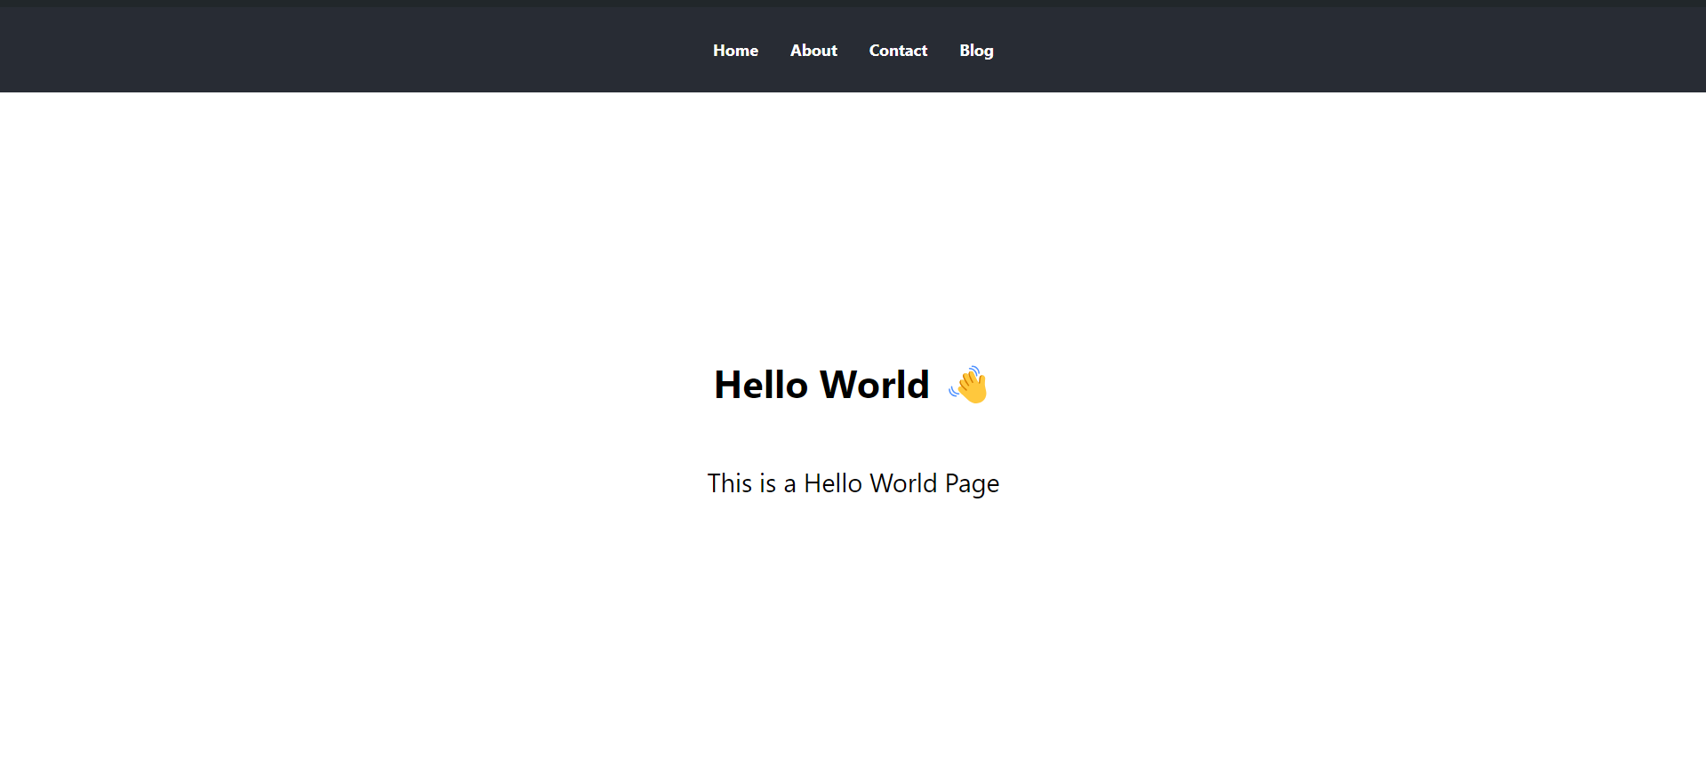

- Create a multiple web page commercial furniture application having a navigation bar using react components having pages such as home, products and customer review.
index.js
import React from 'react';
import ReactDOM from 'react-dom/client';
import './index.css';
import './App.css';
import App from './App';
import reportWebVitals from './reportWebVitals';

const root = ReactDOM.createRoot(document.getElementById('root'));
root.render(
<React.StrictMode>
<App/>
</React.StrictMode>
);
reportWebVitals();

App.js
import "./App.css";
import NavBar from "./components/NavBar";
import Home from "./components/Home";
import Products from "./components/Products";
import Review from "./components/Review";
import { BrowserRouter, Routes, Route } from "react-router-dom";

function App() {
return (
<div>
<BrowserRouter>
<NavBar />
<Routes>
<Route path="/" element={<Home />}>
{" "}
</Route>
<Route path="/reviews" element={<Review />}>
{" "}
</Route>
<Route path="/products" element={<Products />}>
{" "}
</Route>
</Routes>
</BrowserRouter>
</div>
);
}
export default App;

Home.jsx
import React from "react";
import "./Home.module.css";

const Home = () => {
return (
<div>
<header className="App-header">
<div className="home">
<div className="hero-section">
<h1>Welcome to Our Commercial Furniture Store</h1>
<p>
We provide high-quality furniture solutions for
commercial spaces.
</p>
</div>
<div className="about-section">
<h2>About Us</h2>
<p>
We are dedicated to providing durable and stylish
furniture options for businesses, offices,
restaurants, hotels, and more.
</p>
<p>
Our team is committed to delivering exceptional
customer service and ensuring satisfaction with
every purchase.
</p>
</div>
<div className="contact-section">
<h2>Contact Us</h2>
<ul>
<li>Email: info@furniturestore.com</li>
<li>Phone: 123-456-7890</li>
</ul>
</div>
</div>
</header>
</div>
);
};
export default Home;

Home.module.css
.home {
padding: 20px;
}

.hero-section {
text-align: center;
margin-bottom: 50px;
}
.hero-section h1 {
font-size: 36px;
margin-bottom: 20px;
}
.hero-section p {
font-size: 18px;
margin-bottom: 30px;
}
.btn {
display: inline-block;
padding: 10px 20px;
background-color: #007bff;
color: #fff;
text-decoration: none;
border-radius: 5px;
transition: background-color 0.3s ease;
}
.btn:hover {
background-color: #0056b3;
}
.about-section,
.contact-section {
margin-bottom: 50px;
}
.about-section h2,
.contact-section h2 {
font-size: 24px;
margin-bottom: 20px;
}
.about-section p,
.contact-section p {
font-size: 16px;
margin-bottom: 15px;
}
.contact-section ul {
list-style: none;
padding-left: 0;
}
.contact-section li {
font-size: 16px;
margin-bottom: 10px;
}

NavBar.jsx
import React from "react";
import { Link } from "react-router-dom";
import styles from "./NavBar.module.css";
const NavBar = () => {
return (
<nav className={styles.navBar}>
<ul className={styles.navList}>
<li>
<Link to="/">Home</Link>
</li>
<li>
<Link to="/products">Products</Link>
</li>
<li>
<Link to="/reviews">Reviews</Link>
</li>
</ul>
</nav>
);
};
export default NavBar;

NavBar.module.css
.navBar {
background-color: #282c34;
padding: 1em;
}
.navList {
list-style-type: none;
padding: 0;
display: flex;
justify-content: center;
}
.navList li {
margin: 0 1em;
}
.navList li a {
text-decoration: none;
color: white;
font-weight: bold;
}

Furniture.js
import "../App.css";
function Furniture(props) {
return (
<div className="grid-item">
<img
src="https://www.ikea.com/in/en/images/products/trotten-desk-sit-stand-white__1040109_pe840587_s5.jpg?f=xxs"
alt={props.itemName}
className="itemImg"
/>
<h3 className="itemName">Trotten</h3>
<p className="itemPrice">16690</p>
</div>
);
}
export default Furniture;

Products.jsx
import "../App.css";
import Furniture from "./Furniture";

function Products() {
return (
<div className="grid-container App-header App">
<Furniture />
<Furniture />
<Furniture />
<Furniture />
<Furniture />
<Furniture />
<Furniture />
<Furniture />
<Furniture />
</div>
);
}

export default Products;

Review.jsx
import React from "react";
import "../App.css";
const reviews = [
{
id: 1,
name: "John Doe",
rating: 5,
review: "Excellent product! Very satisfied with the quality and performance.",
},
{
id: 2,
name: "Jane Smith",
rating: 4,
review: "Great service! Fast delivery and good customer support.",
},
{
id: 3,
name: "David Brown",
rating: 3,
review: "Product was okay, but could be improved. Delivery was delayed.",
},
];

const Reviews = ({ name, rating, review }) => {
return (
<div className="review">
<h3>{name}</h3>
<div className="rating">Rating: {rating}/5</div>
<p>{review}</p>
</div>
);
};

const CustomerReviews = ({ reviews }) => {
return (
<div className="customer-reviews">
<h2>Customer Reviews</h2>
{reviews.map((review) => (
<Reviews key={review.id} {...review} />
))}
</div>
);
};

const Review = () => {
return (
<div>
<header className="App-header">
<CustomerReviews reviews={reviews} />
</header>
</div>
);
};

export default Review;

App.css
.App {
text-align: center;
width: 97.5vw;
}
.App-logo {
height: 40vmin;
pointer-events: none;
}
@media (prefers-reduced-motion: no-preference) {
.App-logo {
animation: App-logo-spin infinite 20s linear;
}
}

.App-header {
background-color: #282c34;
min-height: 100vh;
display: flex;
flex-direction: column;
align-items: center;
justify-content: center;
font-size: calc(10px + 2vmin);
color: white;
}
.App-link {
color: #61dafb;
}
@keyframes App-logo-spin {
from {
transform: rotate(0deg);
}
to {
transform: rotate(360deg);
}
}
.link {
color: white;
}
.grid-container {
display: inline-grid;
grid-template-columns: auto auto auto;
grid-gap: 20px;
text-align: center;
padding: 20px;
}
.grid-item {
background-color: #f2f2f2;
padding: 20px;
text-align: center;
color: black;
border-radius: 25px;
}
.customer-reviews {
margin: 20px auto;
width: 70%;
}
.review {
border: 1px solid #ccc;
border-radius: 8px;
padding: 20px;
margin-bottom: 20px;
box-shadow: 0 0 10px rgba(0, 0, 0, 0.1);
}
.rating {
font-weight: bold;
margin-bottom: 10px;
}

Output:
Home Page
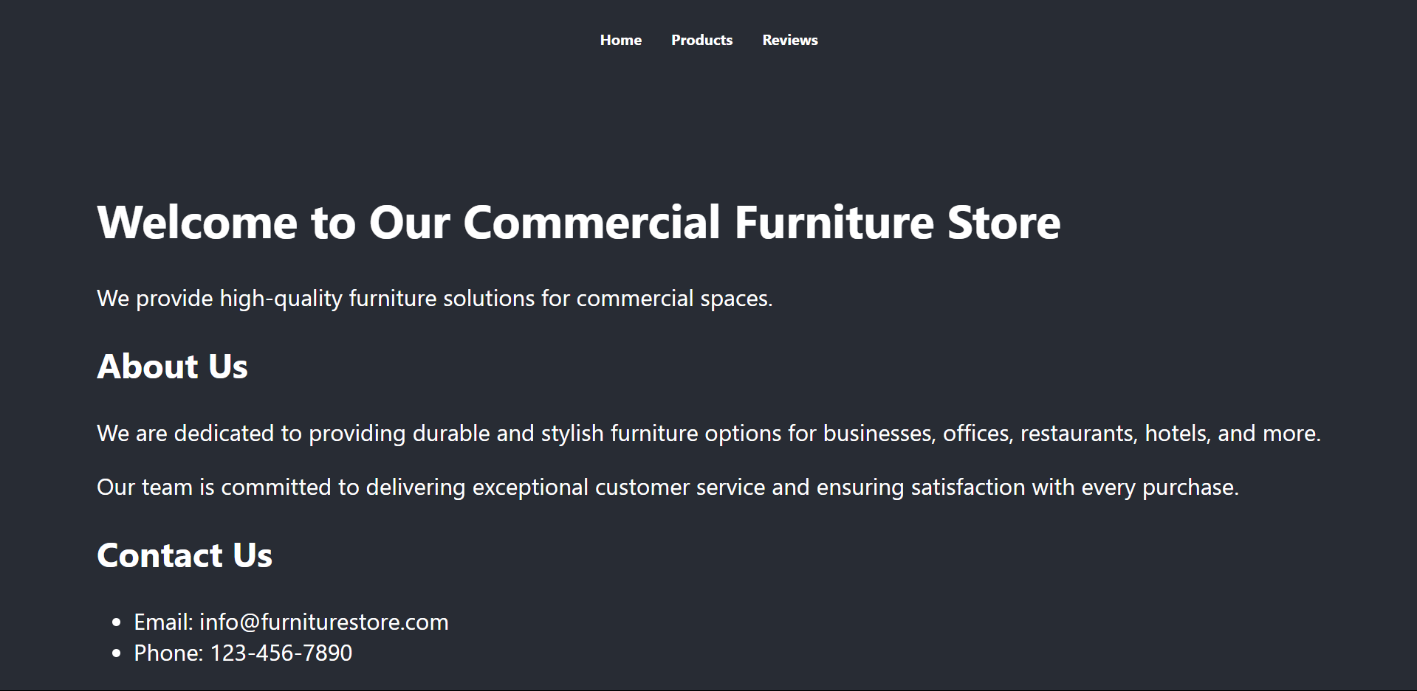

Products Page
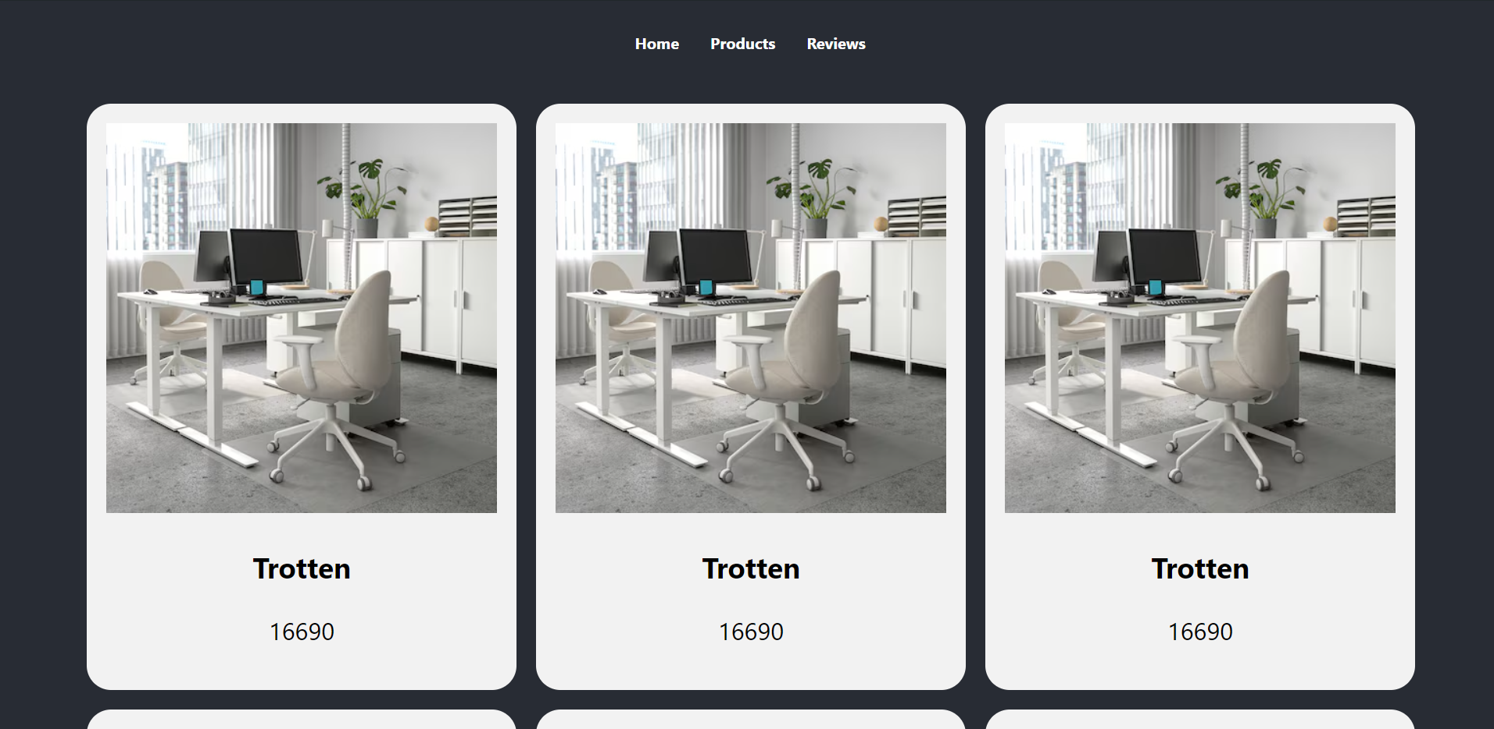
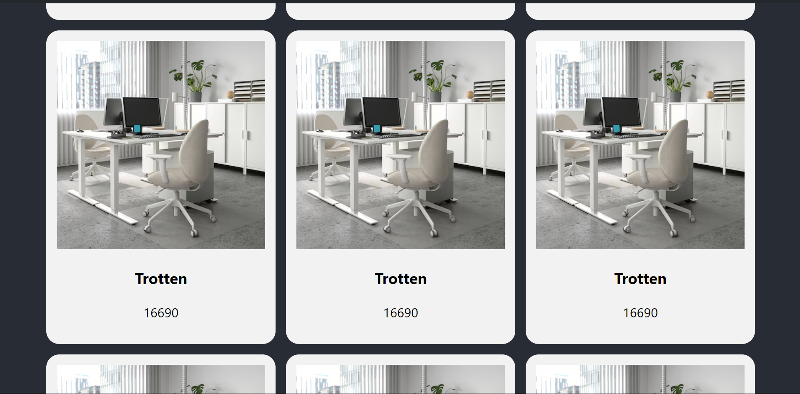

Customer Review page
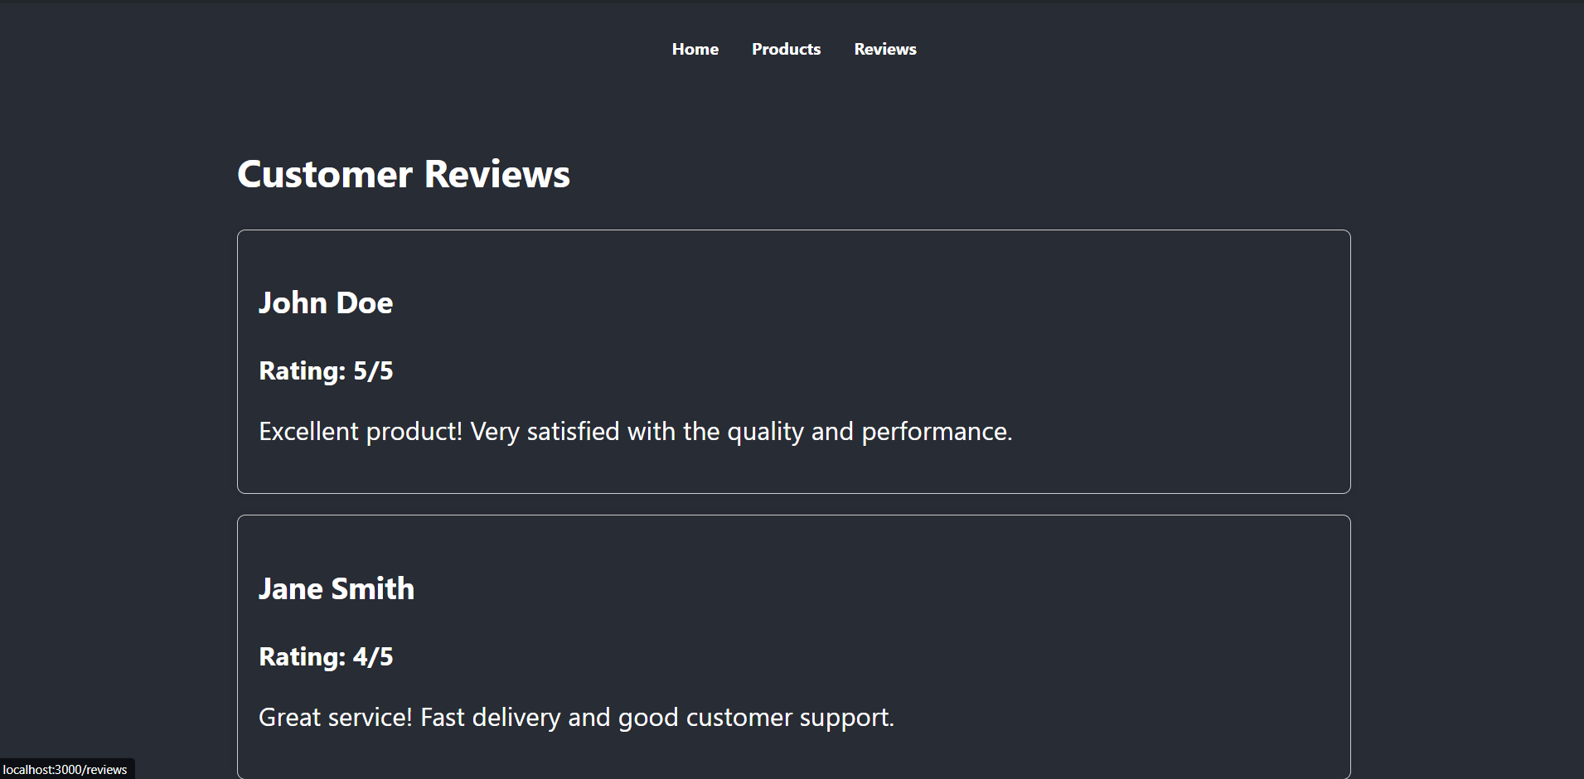
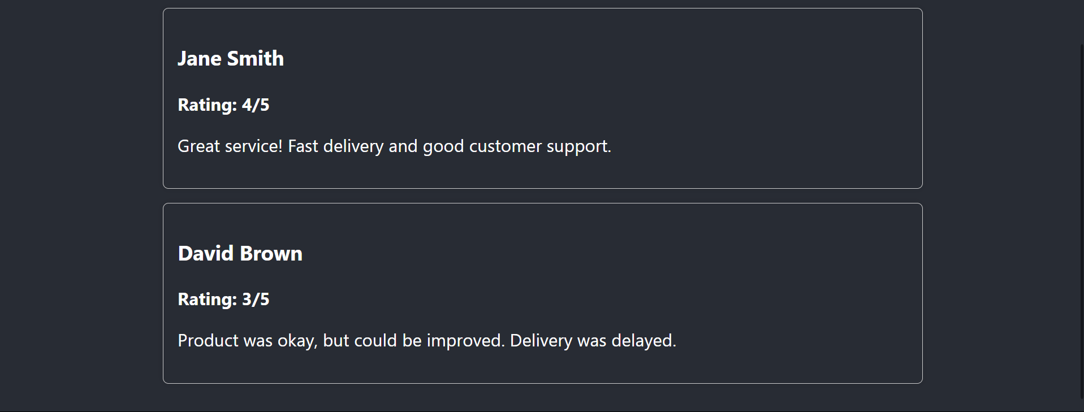

Folder Structure
